Superband v1.1 and 1.2 feature updates

Change control -

04/20/2015 – Initial document.

This document describes converting/updating the Superband 1.1 an 1.2 boards. The pictures are of the 1.1 board but 1.2 is not much different.

Note: Ignore the leaded resistor and the power lead. These are 1.1 updates only. The blue taped item is a double core TX output transformer that we are still testing. Using it shows more consitent drain current across bands. More info as it develops on this change.

Here are the features to be implemented:

- Remove TX output LPF
- Change BPFs to LPFs
- Remove output transformer and ground BNC to ground plane
- Remove opto-isolator and replace with switching Fets
- optionally convert T/R switching to bypass filters on RX
Remove TX output LPF
To remove the LPF, remove C18, C23 and C24. Remove L9 and L11. Place a jumper from left of L9 to bottom hole of L11.

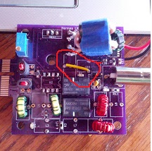
Change BPFs to LPFs.
Remove L1 thru L8. Remove C5 thru C14.

Following the chart below, select the Band 0 and Band 1 filters you want to install and wind toroids.

Install Band 0 toroids in L1 and L2 positions. Install Band 1 toroids in L5 and L6 positions. The other inductor positions are left empty.

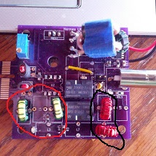

Install wire jumpers as shown in C5, C6, C10 and C11.

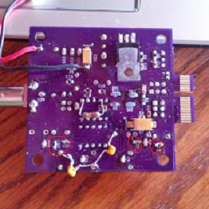

Install capacitors for C8, C9, C13 and C14. For the last capacitor, connect left most L1 hole to ground with a leaded capacitor listed as cy. For Band1, you connect the top hole of L6 to the same ground point. For this picture, I had to use 2 150pf caps to get 300pf value. Ugly but it works.

Note that for the top 3 bands, you need to install a cx value cap across the inductors. Also, for the 160 and 80/75 filters, there are less stages. Install L2 and L5, And caps c8, c9, c13 and c14. Leaded caps for Cy are not used. Cx will be across the 2 inductors with appropriate values for band.

Remove output transformer and ground BNC.
Remove the output transformer as shown. Install a 0.1uf cap across pins 1 and 4 to block DC ground when in receive mode. I jumps across the 4 holes diagonally.

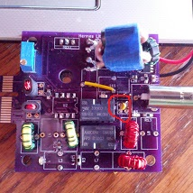

Note: This cap is not necessary if you are going to implement the T/R switching feature. If you do not install that feature, both RX and TX will flow thru the LPFs, attenuating all RX signals above the passband. This will alter the validity of any bandscope software you may be wanting to run.

Provide a better ground for the BNC by scratching off some of the mask on the bottom of the board near the BNC ground, and create a solder bridge or use a short wire.

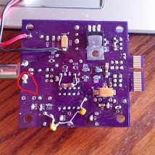
Remove opto-isolator and replace with switching Fets
Remove the opto. Cut the leads and discard. Clean up the pads. Be careful to not lift a pad with excessive heat like I did. I used 2N7000 MOSFETS. Their leads match nicely with the position of the pads. BS170 will also work but the pin configuration is different so be careful. If you get the gate connected wrong, you will blow out your CV PTT or USEROUT4. Don't ask me how I know!

Place some 805 size 10K resistors between pins 1 and 2, and 3 and 4. These are pull down resistors that will insure that PTT is not turned on prior to CV initialization. I was getting a flash on the PTT during power up prior to this change.

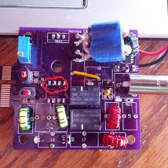

Bend the MOSFETs as shown and install the 2 pins on position 5/6 with the flat side towards the L2 inductor. See later pic for a better view...

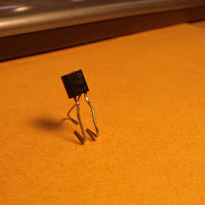

Install the single pin on pin 1.

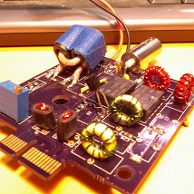

With the next fet, install the 2 pins on position 7/8 and install the single pin on pin 3.

Test your board prior to any more steps.

T/R switching change (optional)
This change is more complex, and completely optional. It requires cutting 3 traces and placing 4 jumpers.

More TBD.

